Mini Project
Title : Student Information Management System

Introduction
The Student Information Management System (SiMS) is a Java-based application developed to efficiently manage student records within an educational institution. It provides an organized way to store, update, and retrieve student details such as ID, name, age, department, year of study, and marks. The project is built using Object-Oriented Programming (OOP) concepts and demonstrates practical implementation of core principles like Encapsulation, Inheritance, Polymorphism, and Abstraction.
The main objective of this system is to reduce the manual workload of managing student data by automating common tasks such as adding new students, searching records, updating details, and deleting entries. The data is also stored persistently using file handling, ensuring that student information is not lost after the program closes.
The project features a Graphical User Interface (GUI) built with Java Swing, making it user-friendly and interactive. Each operation can be performed through buttons and input fields instead of typing commands on the console. This enhances usability and provides a professional appearance similar to real-world applications.
Overall, SiMS serves as a complete mini-project to demonstrate both programming and design skills. It combines theoretical OOP principles with practical software development, showing how core Java features can be applied to solve real-life problems in student data management.

Project Description
The Student Information Management System (SiMS) is a Java-based desktop application designed to simplify and automate the process of managing student records in schools, colleges, and universities. The system provides a digital platform where administrators can easily perform key operations such as adding, viewing, updating, searching, and deleting student details.
This project is developed using Object-Oriented Programming (OOP) concepts in Java, ensuring modularity, reusability, and clarity in the code. The system incorporates essential OOP principles — Encapsulation to protect student data through private variables and getter/setter methods, Inheritance to reuse properties from a base class (Person), Polymorphism to enable method overloading (for searching by ID or name), and Abstraction using an interface (RecordManager) to define standard operations for record handling.
The user interface is built with Java Swing, providing an intuitive and interactive GUI that allows users to perform operations through form inputs and buttons instead of the command line. The system also uses file handling to store student data in a local text or CSV file, ensuring data persistence even after the program closes. Exception handling mechanisms are implemented to manage invalid inputs, duplicate entries, and file errors effectively.
.
Flowchart
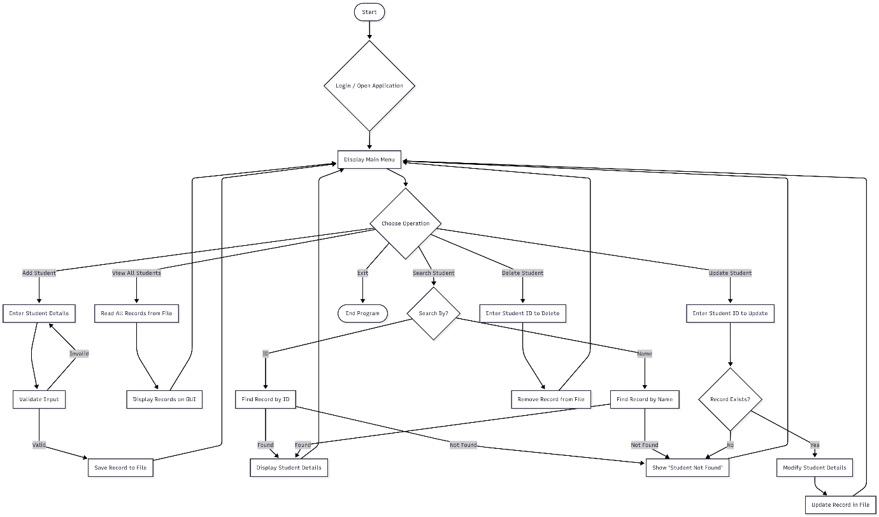

Coding:

import javax.swing.*;
import java.awt.*;
import java.awt.event.*;
import java.io.*;
import java.nio.file.*;
import java.util.*;
import java.util.List;

// Person base class
class Person {
protected String id;
protected String name;
protected int age;

public Person(String id, String name, int age) {
this.id = id;
this.name = name;
this.age = age;
}
}

// Student class
class Student extends Person {
private String department;
private int year;
private double marks;

public Student(String id, String name, int age, String department, int year, double marks) {
super(id, name, age);
this.department = department;
this.year = year;
this.marks = marks;
}

// getters & setters
public String getId() { return id; }
public String getName() { return name; }
public int getAge() { return age; }
public String getDepartment() { return department; }
public int getYear() { return year; }
public double getMarks() { return marks; }

public void setName(String name) { this.name = name; }
public void setAge(int age) { this.age = age; }
public void setDepartment(String department) { this.department = department; }
public void setYear(int year) { this.year = year; }
public void setMarks(double marks) { this.marks = marks; }

public String toCSV() {
// escape commas in name/department if necessary (simple replace)
return escape(id) + "," + escape(name) + "," + age + "," + escape(department) + "," + year + "," + marks;
}

public static Student fromCSV(String line) {
// naive CSV split assuming no embedded commas; using simple approach
String[] parts = line.split(",", -1);
if (parts.length != 6) return null;
try {
String id = unescape(parts[0]);
String name = unescape(parts[1]);
int age = Integer.parseInt(parts[2]);
String dept = unescape(parts[3]);
int year = Integer.parseInt(parts[4]);
double marks = Double.parseDouble(parts[5]);
return new Student(id, name, age, dept, year, marks);
} catch (Exception e) {
return null;
}
}

private static String escape(String s) {
if (s == null) return "";
return s.replace(",", "\\,");
}

private static String unescape(String s) {
if (s == null) return "";
return s.replace("\\,", ",");
}

@Override
public String toString() {
return String.format("ID: %s | Name: %s | Age: %d | Dept: %s | Year: %d | Marks: %.2f",
id, name, age, department, year, marks);
}
}

// RecordManager interface
interface RecordManager {
void addRecord(Student s) throws Exception;
void deleteRecord(String id) throws Exception;
Student searchRecordById(String id);
Student searchRecordByName(String name);
void updateRecord(Student s) throws Exception;
List<Student> getAllRecords();
}

// StudentManager implements file persistence
class StudentManager implements RecordManager {
private final List<Student> students = new ArrayList<>();
private final Path filePath;

public StudentManager(String filename) {
this.filePath = Paths.get(filename);
loadFromFile();
}

@Override
public synchronized void addRecord(Student s) throws Exception {
if (s == null) throw new IllegalArgumentException("Student is null");
if (searchRecordById(s.getId()) != null) throw new Exception("Duplicate ID");
students.add(s);
saveToFile();
}

@Override
public synchronized void deleteRecord(String id) throws Exception {
boolean removed = students.removeIf(st -> st.getId().equalsIgnoreCase(id));
if (!removed) throw new Exception("Student with ID not found");
saveToFile();
}

@Override
public synchronized Student searchRecordById(String id) {
for (Student s : students) {
if (s.getId().equalsIgnoreCase(id)) return s;
}
return null;
}

@Override
public synchronized Student searchRecordByName(String name) {
for (Student s : students) {
if (s.getName().equalsIgnoreCase(name)) return s;
}
return null;
}

@Override
public synchronized void updateRecord(Student updated) throws Exception {
boolean found = false;
for (int i = 0; i < students.size(); i++) {
if (students.get(i).getId().equalsIgnoreCase(updated.getId())) {
students.set(i, updated);
found = true;
break;
}
}
if (!found) throw new Exception("Student not found for update");
saveToFile();
}

@Override
public synchronized List<Student> getAllRecords() {
return new ArrayList<>(students);
}

private synchronized void saveToFile() {
try {
Files.createDirectories(filePath.getParent() == null ? Paths.get(".") : filePath.getParent());
try (BufferedWriter bw = Files.newBufferedWriter(filePath)) {
for (Student s : students) bw.write(s.toCSV() + System.lineSeparator());
}
} catch (IOException e) {
// for GUI app we don't rethrow; errors shown elsewhere
e.printStackTrace();
}
}

private synchronized void loadFromFile() {
students.clear();
if (!Files.exists(filePath)) return;
try (BufferedReader br = Files.newBufferedReader(filePath)) {
String line;
while ((line = br.readLine()) != null) {
Student s = Student.fromCSV(line);
if (s != null) students.add(s);
}
} catch (IOException e) {
e.printStackTrace();
}
}
}

// GUI
public class StudentManagementSystem extends JFrame {
private final StudentManager manager;
private final JTextArea displayArea;

private final JTextField idField = new JTextField();
private final JTextField nameField = new JTextField();
private final JTextField ageField = new JTextField();
private final JTextField deptField = new JTextField();
private final JTextField yearField = new JTextField();
private final JTextField marksField = new JTextField();

public StudentManagementSystem() {
super("Student Information Management System (SiMS)");
// choose file name in working directory
manager = new StudentManager("students.csv");

setDefaultCloseOperation(JFrame.EXIT_ON_CLOSE);
setSize(850, 600);
setLocationRelativeTo(null); // center

JPanel content = new JPanel();
content.setLayout(new BorderLayout(10, 10));
content.setBorder(BorderFactory.createEmptyBorder(10,10,10,10));
setContentPane(content);

// Input grid
JPanel inputGrid = new JPanel(new GridLayout(3, 4, 8, 8));
inputGrid.add(new JLabel("ID:")); inputGrid.add(idField);
inputGrid.add(new JLabel("Name:")); inputGrid.add(nameField);
inputGrid.add(new JLabel("Age:")); inputGrid.add(ageField);
inputGrid.add(new JLabel("Department:")); inputGrid.add(deptField);
inputGrid.add(new JLabel("Year:")); inputGrid.add(yearField);
inputGrid.add(new JLabel("Marks:")); inputGrid.add(marksField);

content.add(inputGrid, BorderLayout.NORTH);

// Buttons
JPanel buttonPanel = new JPanel(new FlowLayout(FlowLayout.LEFT, 10, 10));
JButton addBtn = new JButton("Add");
JButton viewBtn = new JButton("View All");
JButton searchBtn = new JButton("Search");
JButton updateBtn = new JButton("Update");
JButton deleteBtn = new JButton("Delete");
JButton clearBtn = new JButton("Clear Fields");
buttonPanel.add(addBtn); buttonPanel.add(viewBtn); buttonPanel.add(searchBtn);
buttonPanel.add(updateBtn); buttonPanel.add(deleteBtn); buttonPanel.add(clearBtn);

content.add(buttonPanel, BorderLayout.CENTER);

// Display area
displayArea = new JTextArea();
displayArea.setEditable(false);
displayArea.setFont(new Font(Font.MONOSPACED, Font.PLAIN, 12));
JScrollPane scroll = new JScrollPane(displayArea);
scroll.setPreferredSize(new Dimension(800, 350));
content.add(scroll, BorderLayout.SOUTH);

// Button actions
addBtn.addActionListener(e -> onAdd());
viewBtn.addActionListener(e -> onViewAll());
searchBtn.addActionListener(e -> onSearch());
updateBtn.addActionListener(e -> onUpdate());
deleteBtn.addActionListener(e -> onDelete());
clearBtn.addActionListener(e -> clearFields());

// show current records
onViewAll();
}

private void onAdd() {
try {
Student s = readStudentFromFields(true);
manager.addRecord(s);
displayMessage("✅ Student added: " + s.getId());
clearFields();
onViewAll();
} catch (NumberFormatException nf) {
displayMessage("❌ Invalid number format in Age/Year/Marks. Please correct.");
} catch (IllegalArgumentException ia) {
displayMessage("❌ " + ia.getMessage());
} catch (Exception ex) {
displayMessage("❌ " + ex.getMessage());
}
}

private void onViewAll() {
List<Student> all = manager.getAllRecords();
if (all.isEmpty()) {
displayArea.setText("No students found.\n");
return;
}
StringBuilder sb = new StringBuilder();
for (Student s : all) {
sb.append(s.toString()).append("\n");
}
displayArea.setText(sb.toString());
}

private void onSearch() {
String q = JOptionPane.showInputDialog(this, "Enter Student ID or Name to search:");
if (q == null || q.trim().isEmpty()) return;
Student byId = manager.searchRecordById(q.trim());
Student byName = (byId == null) ? manager.searchRecordByName(q.trim()) : byId;
if (byName != null) {
populateFields(byName);
displayArea.setText("Found:\n" + byName.toString());
} else {
displayArea.setText("❌ No student found for: " + q);
}
}

private void onUpdate() {
String id = JOptionPane.showInputDialog(this, "Enter ID of student to update:");
if (id == null || id.trim().isEmpty()) return;
Student existing = manager.searchRecordById(id.trim());
if (existing == null) {
displayMessage("❌ Student with ID not found.");
return;
}
// populate fields so user can edit
populateFields(existing);
int option = JOptionPane.showConfirmDialog(this, "Edit fields and click OK to save changes.", "Update Student", JOptionPane.OK_CANCEL_OPTION);
if (option != JOptionPane.OK_OPTION) {
displayMessage("Update cancelled.");
return;
}
try {
Student updated = readStudentFromFields(false); // id must match
if (!updated.getId().equalsIgnoreCase(existing.getId())) {
displayMessage("❌ ID cannot be changed.");
return;
}
manager.updateRecord(updated);
displayMessage("✅ Student updated: " + updated.getId());
clearFields();
onViewAll();
} catch (NumberFormatException nf) {
displayMessage("❌ Invalid number format in Age/Year/Marks. Please correct.");
} catch (Exception ex) {
displayMessage("❌ " + ex.getMessage());
}
}

private void onDelete() {
String id = JOptionPane.showInputDialog(this, "Enter ID of student to delete:");
if (id == null || id.trim().isEmpty()) return;
int confirm = JOptionPane.showConfirmDialog(this, "Are you sure you want to delete student with ID: " + id + "?", "Confirm Delete", JOptionPane.YES_NO_OPTION);
if (confirm != JOptionPane.YES_OPTION) {
displayMessage("Deletion cancelled.");
return;
}
try {
manager.deleteRecord(id.trim());
displayMessage("✅ Student deleted: " + id);
onViewAll();
} catch (Exception ex) {
displayMessage("❌ " + ex.getMessage());
}
}

private Student readStudentFromFields(boolean requireId) {
String id = idField.getText().trim();
String name = nameField.getText().trim();
String ageStr = ageField.getText().trim();
String dept = deptField.getText().trim();
String yearStr = yearField.getText().trim();
String marksStr = marksField.getText().trim();

if (requireId && id.isEmpty()) throw new IllegalArgumentException("ID is required.");
if (name.isEmpty()) throw new IllegalArgumentException("Name is required.");
if (ageStr.isEmpty() || yearStr.isEmpty() || marksStr.isEmpty())
throw new IllegalArgumentException("Age, Year and Marks are required.");

int age = Integer.parseInt(ageStr);
int year = Integer.parseInt(yearStr);
double marks = Double.parseDouble(marksStr);

return new Student(id, name, age, dept, year, marks);
}

private void populateFields(Student s) {
idField.setText(s.getId());
nameField.setText(s.getName());
ageField.setText(String.valueOf(s.getAge()));
deptField.setText(s.getDepartment());
yearField.setText(String.valueOf(s.getYear()));
marksField.setText(String.valueOf(s.getMarks()));
}

private void clearFields() {
idField.setText("");
nameField.setText("");
ageField.setText("");
deptField.setText("");
yearField.setText("");
marksField.setText("");
}

private void displayMessage(String msg) {
displayArea.setText(msg + "\n");
}

public static void main(String[] args) {
SwingUtilities.invokeLater(() -> {
StudentManagementSystem gui = new StudentManagementSystem();
gui.setVisible(true);
});
}
}

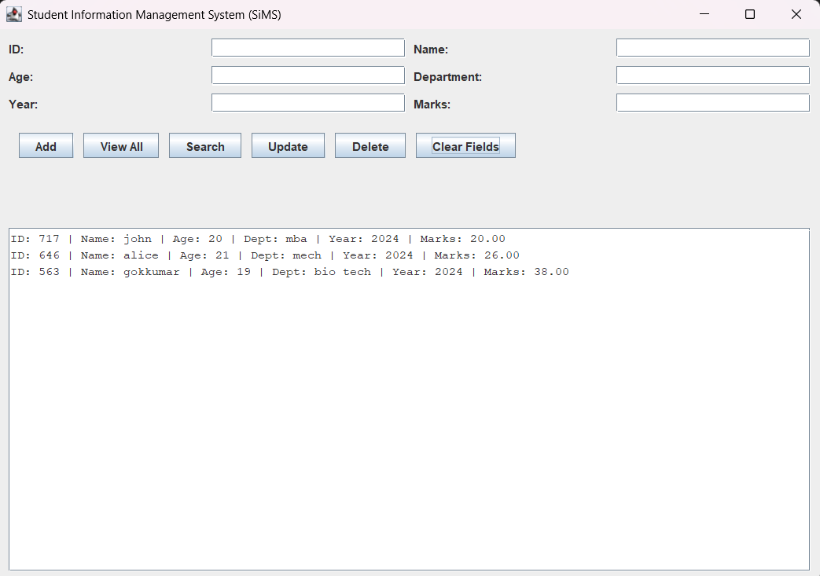

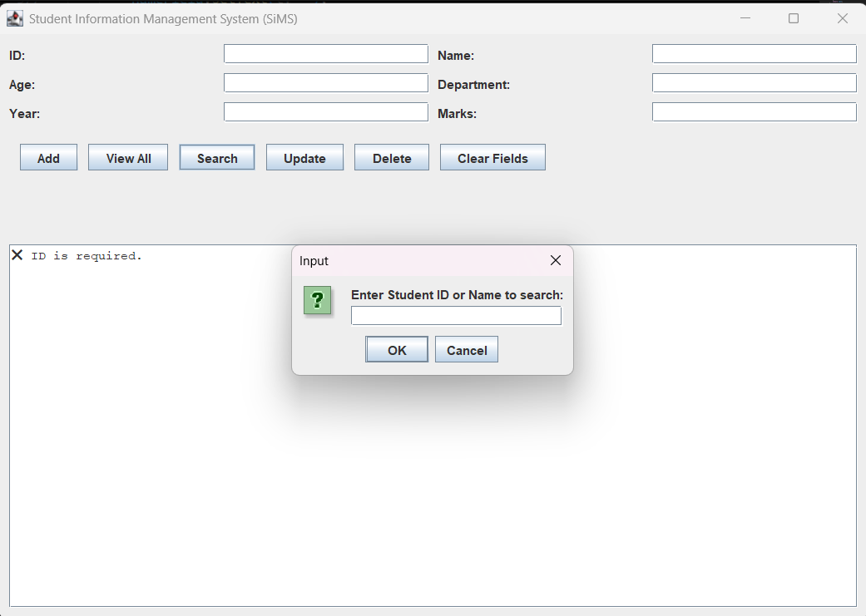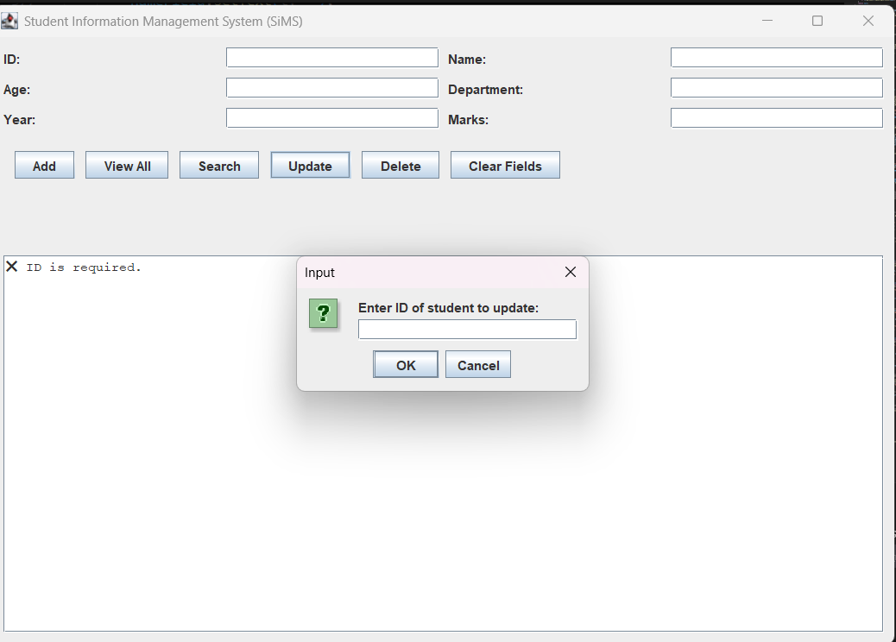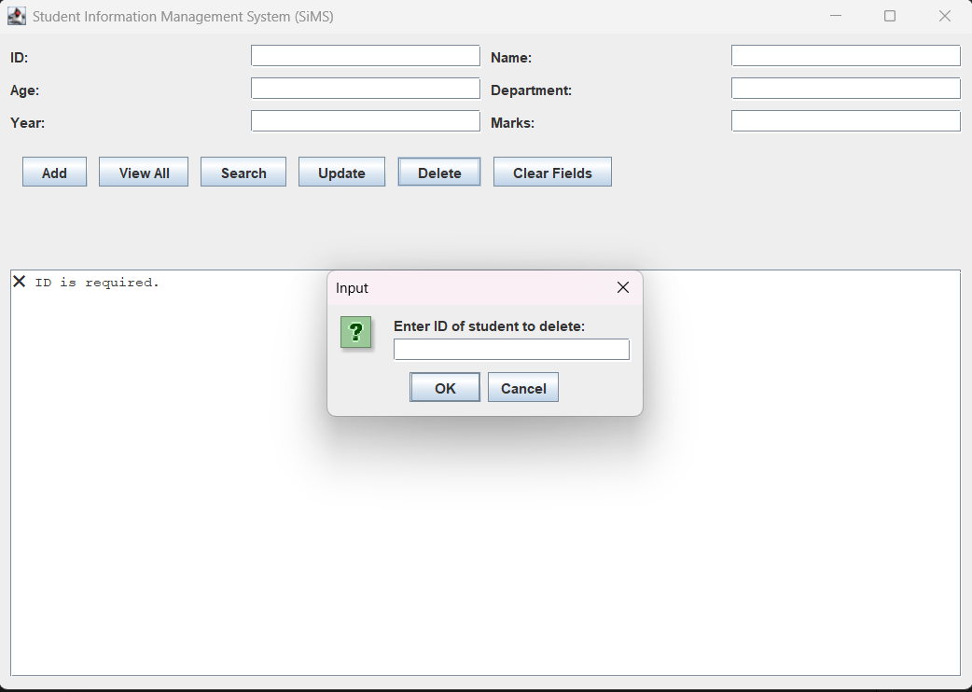

Conclusion & Future Work
The Student Information Management System (SiMS) successfully demonstrates the practical application of Object-Oriented Programming (OOP) principles such as Encapsulation, Inheritance, Polymorphism, and Abstraction.
Through this project, we developed a functional and user-friendly system capable of adding, viewing, updating, deleting, and searching student records efficiently.
The integration of GUI (Java Swing) makes the system interactive and easy to use, while file handling ensures that student data is stored persistently for future use.
Overall, SiMS provides a structured approach to managing academic information, improving efficiency, accuracy, and data organization within an educational environment.

